Data Modification 5(using MySQL server)

DELETE FROM Location

WHERE LocNo = 'L108';

Before Modification:

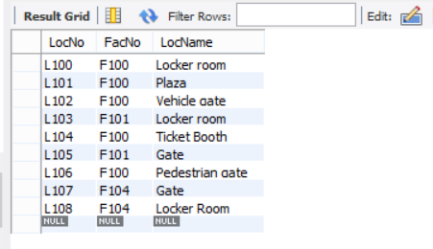

Resulting Table Screenshot:

